**Installation Considerations**

(assuming tightest security and access with no internet access)

**Here are the primary TagUI files, including MS Office Add-ins -**

* [TagUI v6.46 for Windows](https://github.com/kelaberetiv/TagUI/releases/download/v6.46.0/TagUI_Windows.zip), [TagUI v6.46 for macOS](https://github.com/kelaberetiv/TagUI/releases/download/v6.46.0/TagUI_macOS.zip), [TagUI v6.46 for Linux](https://github.com/kelaberetiv/TagUI/releases/download/v6.46.0/TagUI_Linux.zip)
* [OpenJDK for Windows](https://corretto.aws/downloads/latest/amazon-corretto-8-x64-windows-jdk.msi) (needed for computer vision, OCR, low-level keyboard and mouse control, used by SikuliX automation engine packaged with TagUI)
* [Word Add-in v3](https://github.com/kelaberetiv/TagUI/releases/download/v6.64.0/TagUIWordAddInSetupV3.09.zip)
* [Excel Add-in v3](https://github.com/kelaberetiv/TagUI/releases/download/v6.64.0/TagUIExcelAddInSetupV3.05.zip)

**And the secondary files (for latest version and in case something missing) -**

1. The Chrome extension is also contained within the TagUI v6.46 zip file (under tagui\src\chrome). If Chrome Web Store is blocked, the extension can be installed using that folder from Chrome --> Settings --> Extensions page.

2. This file is also required - [Visual C++ Redistributable](https://tagui.readthedocs.io/en/latest/_downloads/fbf25f6118d2d4ab7642688b0da8bfa0/vcredist_x86.exe), in case some computers do not have other programs installed that have this commonly used Microsoft library.

3. v6.46 was released in June 2021, I'll recommend also including this delta zip file so that you can have the option of using the [latest features / bug fixes](https://github.com/kelaberetiv/TagUI/issues?q=is%3Aissue+is%3Aopen+in%3Atitle+fixed+OR+done+) if you want to - <https://github.com/kelaberetiv/TagUI/archive/master.zip> (to use, unzip, drag and drop everything inside tagui\src folder to the unzipped TagUI v6.46 tagui\src folder)

4. There are 2 more files to make sure the Microsoft Office Add-ins can work on [Visual Studio Tools for Office runtime](https://docs.microsoft.com/en-us/visualstudio/vsto/how-to-install-the-visual-studio-tools-for-office-runtime-redistributable?view=vs-2019). Normally the Add-ins during setup will automatically download the following 2 files if needed, but if your laptop has no internet access then better to have a copy of the offline files. [File 1 Microsoft .NET Framework 4.5](https://www.microsoft.com/en-us/download/details.aspx?id=30653)  and [File 2 Visual Studio 2010 Tools for Office](https://www.microsoft.com/en-us/download/details.aspx?id=56961)

**Whitelisting Considerations**

**List of files to whitelist -**

tagui\src\tagui.cmd - to start TagUI

tagui\src\end_processes.cmd - to kill dead processes

tagui\src\phantomjs\bin\phantomjs.exe (TagUI uses as JavaScript execution engine)

tagui\src\casperjs\bin\casperjs.exe (TagUI uses as wrapper layer for PhantomJS)

tagui\src\unx\*.exe (8 supporting .exe commands for pre-processing TagUI scripts)

tagui\src\php\php.exe (TagUI uses PHP to parse human language, and run integrations)

tagui\src\sikulix\sikulix.jar - for computer vision, direct control of keyboard and mouse

jython-standalone-2.7.1.jar - same as above (after 1st run, will move to user-specific folder)

java.exe (user-specific location, depends on where user installs) - to run sikulix.jar and jython

**If other than .exe .cmd files, .py .php .js .dll files also need to whitelist -**

.py .php .js files within tagui\src and subfolder - to run various functions and integrations

tagui\chrome\*.js files (Chrome extension JavaScript files required to run the extension)

various *.dll files in tagui\src\php folder (required for tagui\src\php\php.exe to run)

various *.dll (dynamically linked library) files, which are also programs, in below folders –

C:\Program files\AISG\TagUIWordAddInSetup & C:\Program files\AISG\TagUIExcelAddInSetup

**Enterprise Security by Design**

**Security Considerations**

* TagUI default implementation is an on-user-computer on-prem RPA tool that does not exist on any cloud
* TagUI is not a SaaS or software on the cloud running on vendor's cloud, it runs on actual users' computers
* Industry-specific certifications like PCI-DSS, HIPAA, SOX aren't applicable because TagUI doesn't store data
* In decentralised bottom-up RPA, not advisable and no need for bot credentials as users are held accountable

**Data Considerations**

* For data at rest, storage encryption would be on user's computer's OS-level as it is run on user's computer
* For data in use, recommend user to manually enter sensitive info like password before letting robot take over
* For data in motion, users' enterprise app websites are now https by default for secure data entry and retrieval

**More Information**

* With -report option, there is a summary and detailed logs of robots, with support for centralised reporting

**Architecture and Dependencies**

[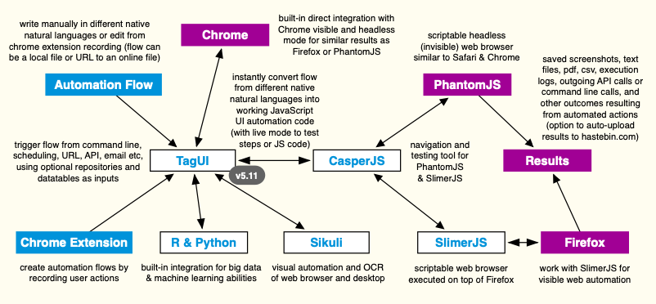](https://raw.githubusercontent.com/kelaberetiv/TagUI/master/src/media/flowchart.png)

As TagUI and the foundation it's built on is open-source software, it means users can read the source code of TagUI and all its dependencies to check if there is a security flaw or malicious code. This is an advantage compared to using commercial software that is closed-source, as users cannot see what is the code behind the software.

Following are links to the source code for TagUI and its open-source dependencies. You can dig through the source code for the other open-source dependencies below, or make the fair assumption that security issues would have been spotted by users and fixed, as these projects are mature and have large user bases.

* TagUI - <https://github.com/kelaberetiv/TagUI>
* SikuliX - <https://github.com/RaiMan/SikuliX1>
* CasperJS - <https://github.com/casperjs/casperjs>
* PhantomJS - <https://github.com/ariya/phantomjs>
* SlimerJS - <https://github.com/laurentj/slimerjs>
* Python - <https://github.com/python/cpython>
* R - <https://github.com/wch/r-source>
* PHP - <https://github.com/php/php-src>

Following are further comments specific to TagUI on the topic of security -

* TagUI allows running of automation files whether they are stored locally as a file on your laptop or computer, or if the file is an online URL. This means users should be cautious to run automation from online URLs unless they are sure that the online URL is a safe source and not doing something destructive. This can be checked by accessing the URL using a web-browser to see the automation steps performed in the online automation file.
* TagUI comes with a web service, that can be used to trigger automation flows if TagUI is installed on a web-server. See [Developers Reference under API](https://github.com/kelaberetiv/TagUI/tree/pre_v6#api). The design minimizes security risk by not forcing users to turn on exec() for their PHP configuration. This means execution of malicious commands cannot be injected through the web-service. Instead, the web-service works by using crontab to periodically check for automation requests. Webservice execution of online flows is now disabled by default so that malicious users cannot trigger execution of a malicious flow hosted online on the webserver.
* As TagUI can replicate what a normal human user can do on the computer, TagUI is restricted and compliant to the same security policies as the normal human user would be subjected to. For example, having to use a hardware token in order to access the laptop, or user password in order to login to the computer. Or having a 2FA hardware token in order to access confidential information from a web or enterprise application.